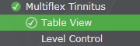
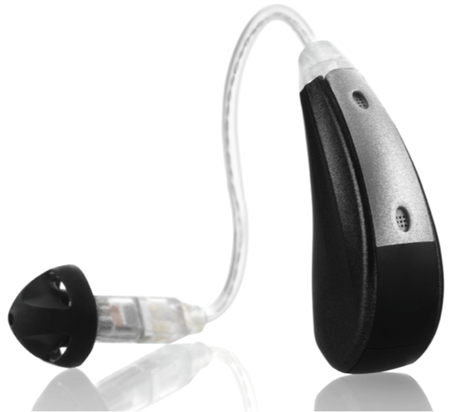
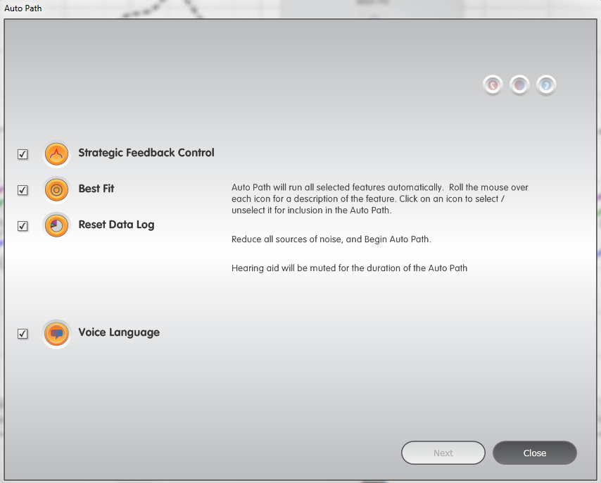
Propel Tinnitus—Initial Fitting Made Easy
User Control Configuration (UCC) opens automatically as part of Auto Path. It may be accessed manually from QuickFit, Fine Tuning, Memories and Fitting Summary. The UCC dialog box will update based on the detected device.
Volume Control Configuration Options
Volume Control (VC) only
Memory only
Tinnitus Stimulus only
VC (short press) + Tinnitus Stimulus (press & hold)
Memory (short press) + Tinnitus Stimulus (press & hold)
- Best Fit will match the frequency response to the selected fitting formula target. It also returns all advanced features and indicators to default settings.
- Target Match will match the frequency response to the selected fitting formal. It does not return advanced features and indicators to default settings.
Auto Path
Product Availability:
Propel Tinnitus

Required Inspire Adjustments
- Connect the Propel Tinnitus RIC 10 to the Programmer by plugging the programming cable into the port in the battery compartment
- Connect hearing aids to the fitting computer via the appropriate programming accessories
- Auto Path launches automatically when hearing aids that have not been previously read are detected by Inspire
- Ensure all icons are checked and highlighted in orange
- Click Next to start the routine
- Follow all onscreen prompts
- Make sure Receiver Matrix and Acoustic Options selection in Inspire match device configuration to accurately reflect the frequency response
- Choose the Voice Language for Indicators
- Click Next
- Select Experience Level
- Click Close to exit Auto Path and this will open Quick Fit
- Make adjustments to hearing aid frequency response gain and features as needed
- Click on Multiflex Tinnitus from the left navigation bar
- Click on the Memory Tabs in the lower corner of the frequency response graphs to enable or disable the tinnitus stimulus per memory
- Enable or Disable Multiflex Tinnitus on a per memory basis by checking or un-unchecking the Enable Tinnitus Stimulus checkbox in the Table View
- Ensure patient comfort with the tinnitus stimulus settings
- Confirm that hearing aid settings and tinnitus stimulus settings are comfortable for the patient
- For optional tinnitus adjustments, please refer to the back of this QuickTIPS

Troubleshooting Multiflex Tinnitus
Due to the variability in patient preferences, there are no fixed guidelines for setting a tinnitus stimulus. Listed below are suggested adjustments for common patient complaints.
Complaint | Recommendation
Tinnitus stimulus is too loud | Decrease overall tinnitus stimulus level via Table View
Tinnitus stimulus is too soft | Increase overall tinnitus stimulus level via Table View
Tinnitus stimulus is distracting | Use SoundPoint Tinnitus  Disable the stimulus in one memory  Decrease overall level of the stimulus  Enable modulation at desired rate
Tinnitus stimulus has a hissy sound quality | Use SoundPoint Tinnitus  Decrease high frequency bands  Increase low frequency bands
Tinnitus stimulus has a roaring sound quality | Use SoundPoint Tinnitus  Decrease low frequency bands  Increase high frequency bands

Optional Inspire Adjustments
SoundPoint Tinnitus (highly recommended)
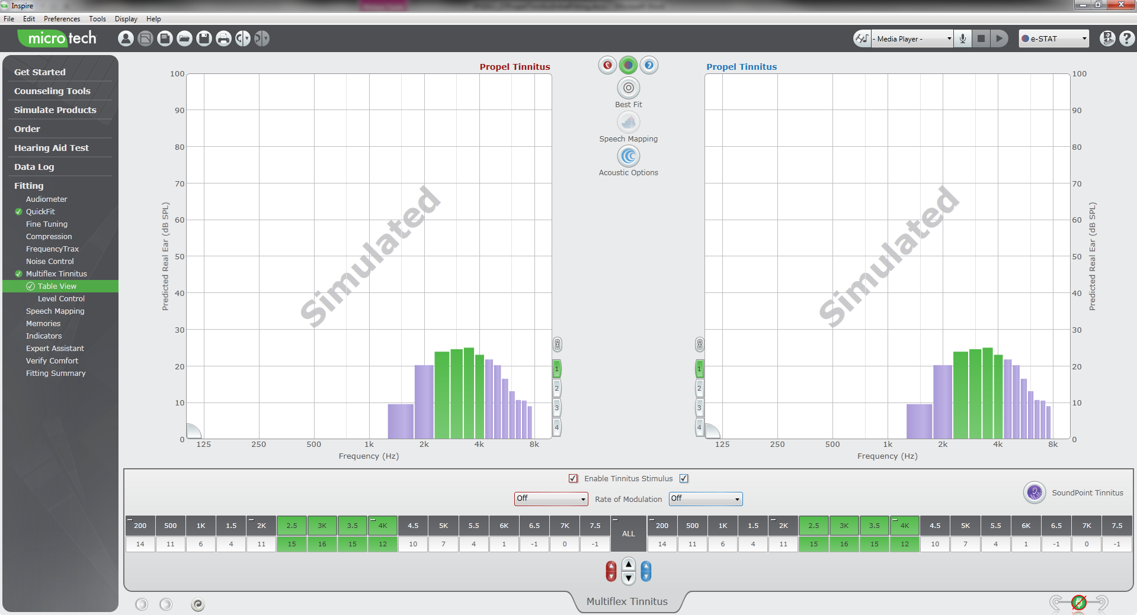
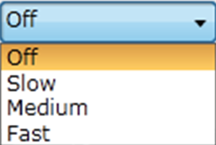
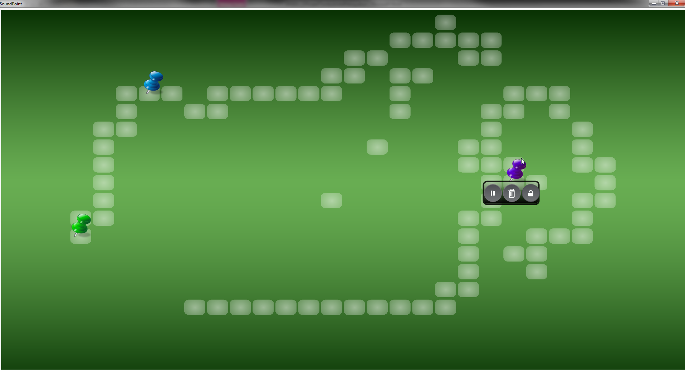
- Select Multiflex Tinnitus from the left navigation bar
- Modulation, if activated, is disabled during the SoundPoint Tinnitus process.
- It will need to be re-enabled following SoundPoint Tinnitus.
Multiflex Tinnitus Table View
Rate of Modulation
SoundPoint Tinnitus
- Click on the SoundPoint Tinnitus icon in the Table View
- Select the method for using SoundPoint Tinnitus (iPad or Desktop/Laptop)
- Choose the Memory in which to begin SoundPoint Tinnitus
- Instruct the patient to navigate the SoundPoint Tinnitus space while listening for audible changes to the stimulus until they locate the best sound setting for them
- Instruct the patient to tap the iPad screen or click the mouse to place a push pin on preferred space(s)
- Hover over one of the push pins to display the tool menu
- Click the lock icon
- Toggle between settings to compare two or more spaces
- Tap the iPad screen or click the mouse on the preferred space to place a star
- Select “Yes, Save to Device”
- Select Yes, Save to Devices!
- Select a second memory if needed or click the Exit SoundPoint button

Rate of Modulation
- Select Multiflex Tinnitus from the left navigation bar
- Click on the drop down box next to Rate of Modulation in the Table View
- Demonstrate each rate to determine patient preference
Frequency Response Shaping
- Select Multiflex Tinnitus from the left navigation bar
- Choose a specific frequency, frequency region or entire stimulus response using the Table View
- Increase or decrease the level of the tinnitus stimulus in the selected region(s) based on patient preference
Determine Memory Settings
- Select Multiflex Tinnitus from the left navigation bar
- Select desired environments from the memory tabs at the lower corner of the frequency response graphs
- Click on each Memory Tab to display each enabled memory
- Enable or Disable Multiflex Tinnitus on a per memory basis by checking or un-unchecking the Enable Tinnitus Stimulus checkbox in the Table View

Setting for normal hearing
- In normal hearing cases the hearing aid will provide some amplification simply to overcome insertion gain loss.
- This “on-effect” is typically accepted by the majority of users however, for patients who report that even the slight amplification is bothersome or annoying (especially when there is wind turbulence or turbulence due to hair over the microphones) the following steps can be taken to improve the users experience.
- Best fit the Tinnitus device as normal
- Decrease the gain in all channels as far as possible.
- Adjust the tinnitus stimulus as required.
- Setting a Mute program will also turn off the aid microphones and the tinnitus stimulus can be adjusted as normal.

