Steps for Success—An Initial Fitting Protocol
Product Availability:
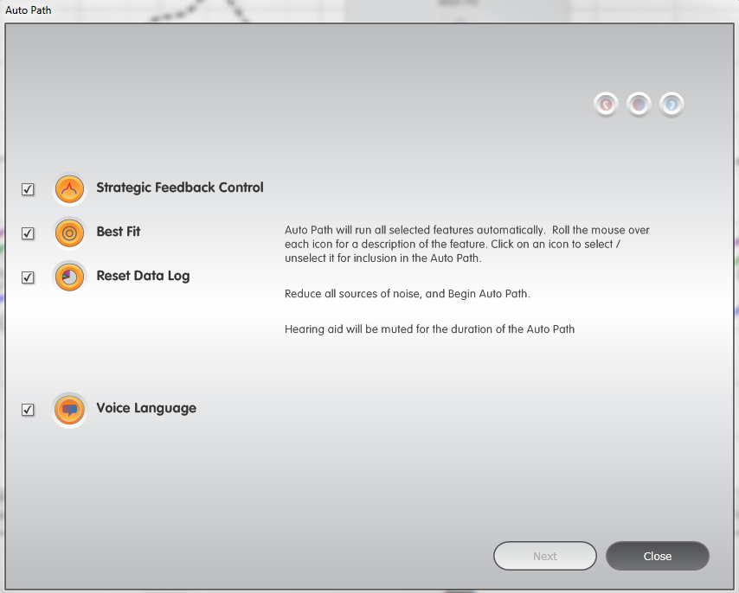
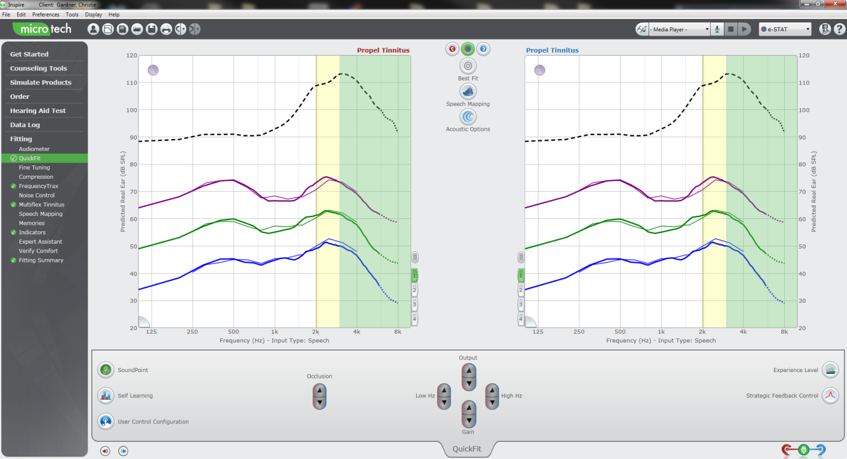
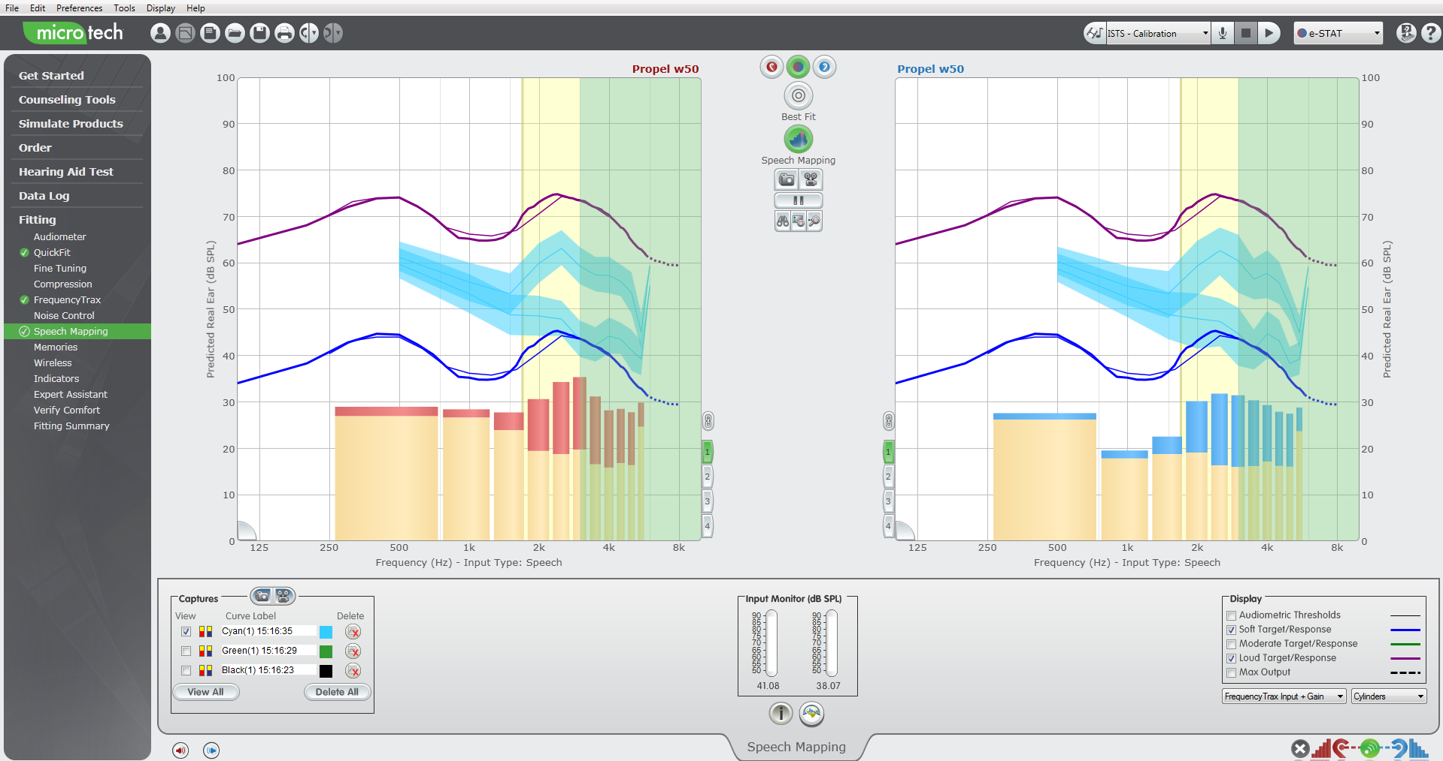
Propel, Propel Tinnitus.
Inspire Auto Path
- Programming cables and connectors spreadsheet is available via Inspire Online
- Auto Path protocol varies based on product family and technology level
- Select Experience Level 3 for patients experienced with amplification
- Select Experience Level 1 for patients new to amplification
QuickFit
Speech Mapping

Required Inspire
- Connect hearing aids to the fitting computer via the appropriate programming accessories
- Auto Path launches automatically when hearing aids that have not been previously read are detected by Inspire
- Ensure all icons are checked and highlighted in orange
- Click Next to start the routine
- Follow all onscreen prompts
- Make sure Receiver Matrix and Acoustic Options selection in Inspire must match device configuration to accurately reflect the frequency response
- Choose the Voice Language for Indicators
- Click Next
- Select Experience Level
- Click Close to exit Auto Path and open Quick Fit

QuickFit
- Use the controls in the bottom center of the QuickFit screen to adjust for patient comments regarding output, gain and occlusion
- Click on the User Control Configuration icon to enable the user control as memory, volume control, or both. (Propel Tinnitus also offers an adjustment for the tinnitus level)
- Enable Memory 4 as the preferred automatic telephone response via the memory tabs in lower corner of the frequency response screen

Speech Mapping
- Click on Speech Mapping in the left navigation bar
- Place a check for soft (50) and loud (80) Target and Response curves in the Display menu
- Select the movie camera icon to capture a 10 second video using live or recorded voice
- Ensure the top capture is between the soft and loud curves to demonstrate audibility and comfort
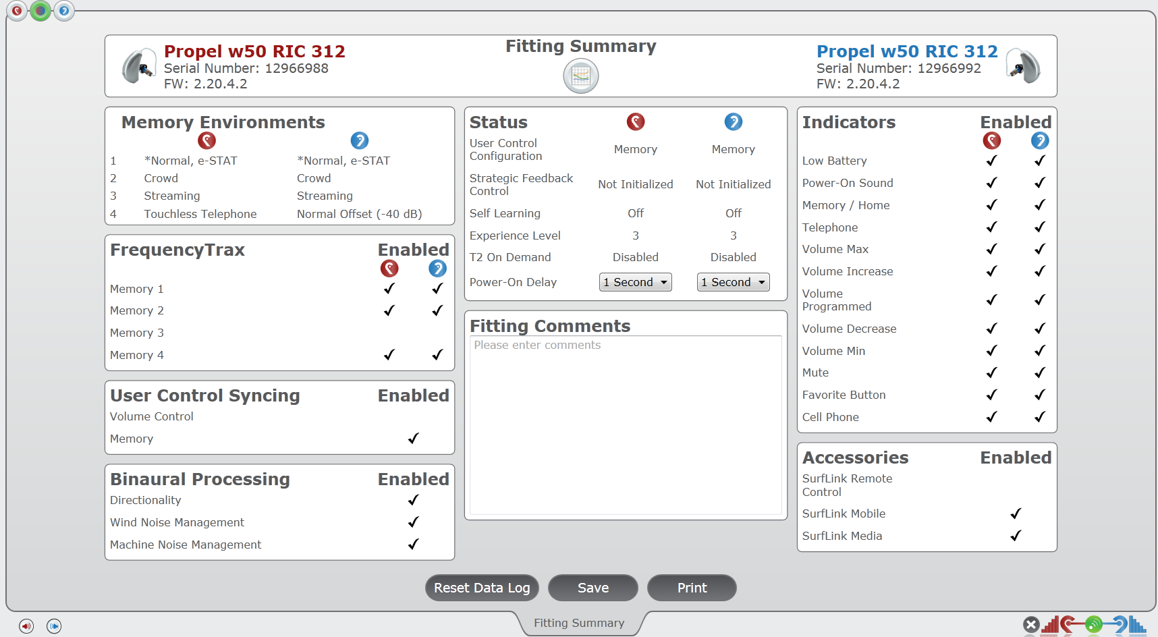
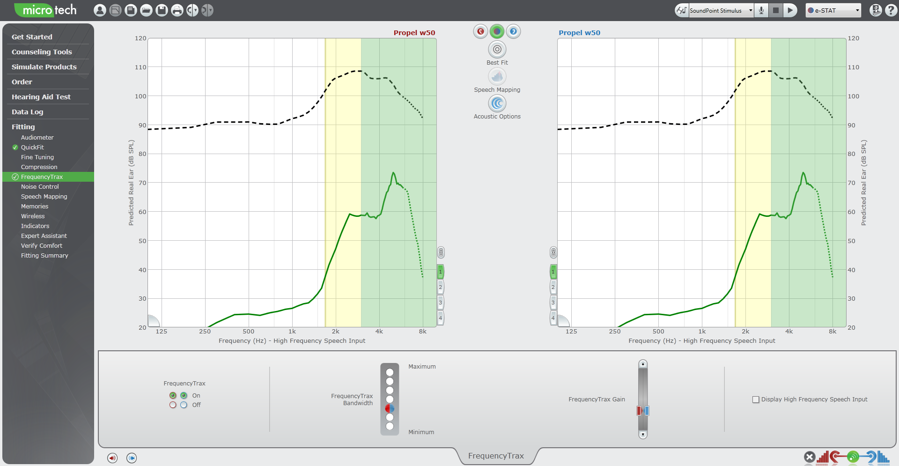
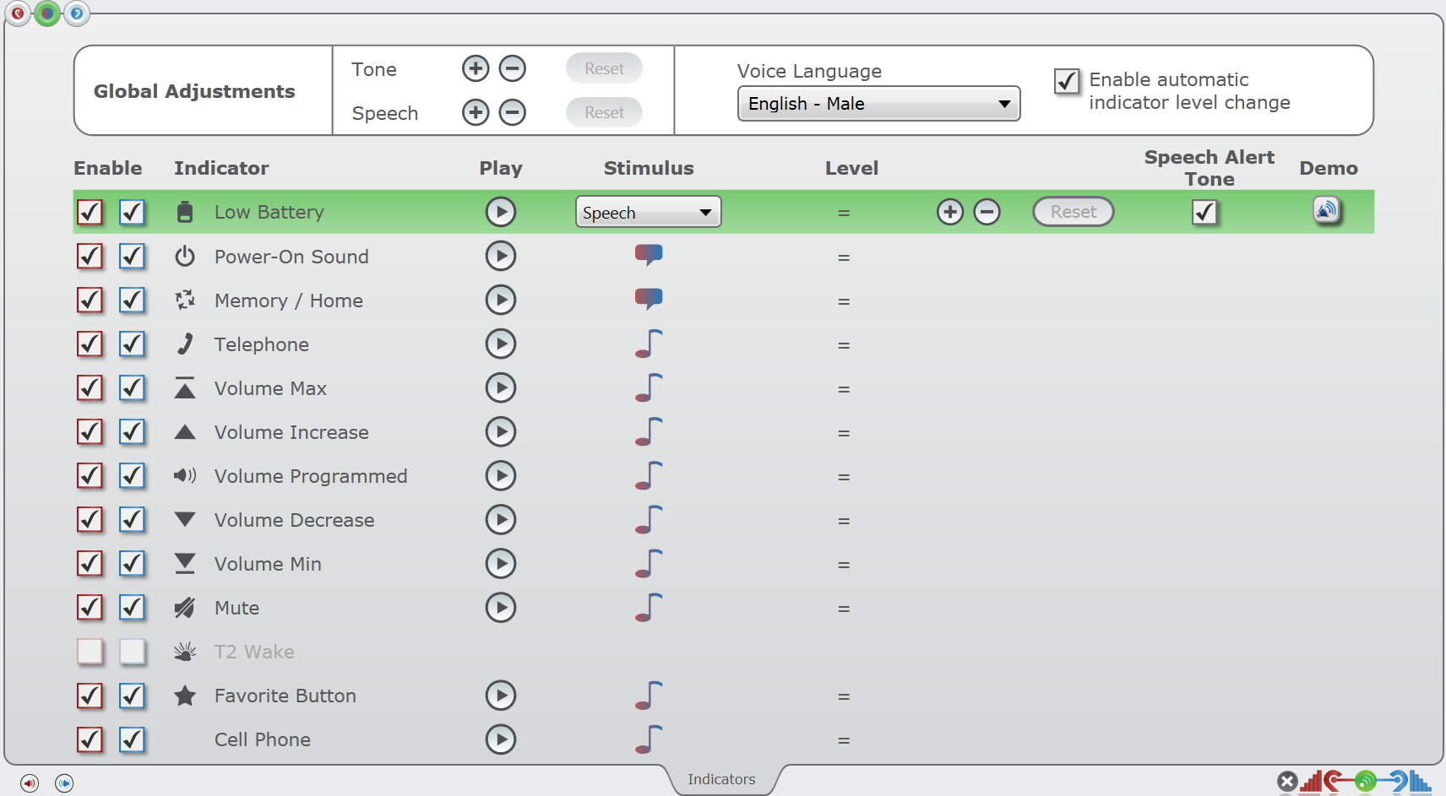
FrequencyTrax
Fitting Summary
FrequencyTrax in Inspire

Indicators Screen
- Click on FrequencyTrax on the left navigation bar
- Bandwidth adjusts the Source and Target regions to maximize speech clarity
- Gain adjusts the amplification of the recreated cues to maximize audibility (ten 1dB increment steps)
- Expert Assistant accessed via the left navigation bar or QuickFit screen included additional fine tuning assistance
- Click on the Memory Tabs in the lower corner of the frequency response graphs to enable or disable FrequencyTrax per memory

Indicators
- Select Indicators from the left navigation bar
- Click on an Indicator icon to highlight it to verify audibility
- Use the Play icon to test audibility through the hearing aid
- Use the Speaker icon to demo the indicator through the computer speakers
- Use the + icons to increase or decrease presentation level as needed
- Languages may be adjusted from this screen
- Available Voice Languages may be demonstrated via the Media File Player

Fitting Summary
- Select Fitting Summary from the left navigation bar
- Hover over any screen label to highlight the hyperlink
- Click on the hyperlink to navigate to the adjustment screen if needed
- Enter detailed Fitting comments and save or print to the patient’s file if required.

